

| **Course Code:** | **CSE111** |
| --- | --- |
| **Course Title:** | **Programming Language II** |
| **Classwork No:** | **07** |
| **Topic:** | **OOP (inheritance)** |
| **Number of tasks:** | **3** |

**Task 1**

The tea company **Kazi and Kazi (KK)** has decided to produce a new line of flavored teas. Design the **KK_tea (parent) and KK_flavoured_tea (child)** classes so that the following output is produced. The KK_flavoured_tea class should inherit KK_tea. Note that:

* An object of either class represents a **single box of teabags**.
* Each tea bag **weighs 2 grams**.
* The **status** of an object refers to whether it is sold or not

*Hint: you should use class methods/variables*

| **t1 = KK_tea(250)**  **print("-----------------1-----------------")**  **t1.product_detail()**  **print("-----------------2-----------------")**  **KK_tea.total_sales()**  **print("-----------------3-----------------")**  **t2 = KK_tea(470, 100)**  **t3 = KK_tea(360, 75)**  **KK_tea.update_sold_status_regular(t1, t2, t3)**  **print("-----------------4-----------------")**  **t3.product_detail()**  **print("-----------------5-----------------")**  **KK_tea.total_sales()**  **print("-----------------6-----------------")**  **t4 = KK_flavoured_tea("Jasmine", 260, 50)**  **t5 = KK_flavoured_tea("Honey Lemon", 270, 45)**  **t6 = KK_flavoured_tea("Honey Lemon", 270, 45)**  **print("-----------------7-----------------")**  **t4.product_detail()**  **print("-----------------8-----------------")**  **t6.product_detail()**  **print("-----------------9-----------------")**  **KK_flavoured_tea.update_sold_status_flavoured(t4, t5, t6)**  **print("-----------------10-----------------")**  **KK_tea.total_sales()** | **-----------------1-----------------**  **Name: KK Regular Tea, Weight: 100**  **Tea Bags: 50, Price: 250**  **Status: False**  **-----------------2-----------------**  **Total sales: {'KK Regular Tea': 0}**  **-----------------3-----------------**  **-----------------4-----------------**  **Name: KK Regular Tea, Weight: 150**  **Tea Bags: 75, Price: 360**  **Status: True**  **-----------------5-----------------**  **Total sales: {'KK Regular Tea': 3}**  **-----------------6-----------------**  **-----------------7-----------------**  **Name: KK Jasmine Tea, Weight: 100**  **Tea Bags: 50, Price: 260**  **Status: False**  **-----------------8-----------------**  **Name: KK Honey Lemon Tea, Weight: 90**  **Tea Bags: 45, Price: 270**  **Status: False**  **-----------------9-----------------**  **-----------------10-----------------**  **Total sales: {'KK Regular Tea': 3, 'KK Jasmine Tea': 1, 'KK Honey Lemon Tea': 2}** |
| --- | --- |

**Task 2**

Given a 2D vector class, design the 3D vector class that inherits 2D vector. You need to implement the following features:

* Similar to X and Y of 2D vector, Z of 3D vector will be a private variable. Hence, write methods that allow access to private variables.
* Write a method **add3DVectors()** that adds 3D vectors. It **must reuse** the **add2DVectors()** function and be written with the same parameters. The only difference is that, in 3D vectors, the Z components are added as well.
* Write a **multiplyScalar()** method that takes an integer as parameter and multiplies it with all 3 components separately (scalar multiplication). Keep in mind that the X and Y variables are private.
* Write a **calculateLength()** that returns the length of the 3D vector using the following formula:
$\sqrt{X^{2}+ Y^{2}+Z^{2}}$

* Write a **print3DVector()** similar to the **print2DVector()** method.
* 2D vector: Xi + Yj

3D vector: Xi + Yj + Zk

**class TwoDVector:**

**def __init__(self, x, y):**

**self.__x = x**

**self.__y = y**

**# Setter and Getter Methods for x & y**

**def add2DVectors(self, *vectors):**

**for i in vectors:**

**self.__x += i.__x**

**self.__y += i.__y**

**def print2DVector(self):**

**if self.__y >= 0:**

**y = "+ "+str(self.__y)**

**else:**

**y = str(self.__y)**

**print(f"{self.__x}i {y}j")**

| **TwoDV1 = TwoDVector(5, 6)**  **TwoDV2 = TwoDVector(3, 7)**  **TwoDV3 = TwoDVector(1, 8)**  **print("===============")**  **TwoDV1.add2DVectors(TwoDV2, TwoDV3)**  **TwoDV1.print2DVector()**  **print("===============")**  **ThreeDV1 = ThreeDVector(5, 6, 1)**  **ThreeDV2 = ThreeDVector(1, 9, -7)**  **ThreeDV3 = ThreeDVector(8, 2, 4)**  **print("===============")**  **ThreeDV1.add3DVectors(ThreeDV2,ThreeDV3)**  **ThreeDV1.print3DVector()**  **print("===============")**  **ThreeDV1.multiplyScalar(3)**  **ThreeDV1.print3DVector()**  **print("===============")**  **print(ThreeDV1.calculateLength())** | **===============**  **9i + 21j**  **===============**  **===============**  **14i + 17j -2k**  **===============**  **42i + 51j -6k**  **===============**  **66.34003316248794** |
| --- | --- |

**Task 3**

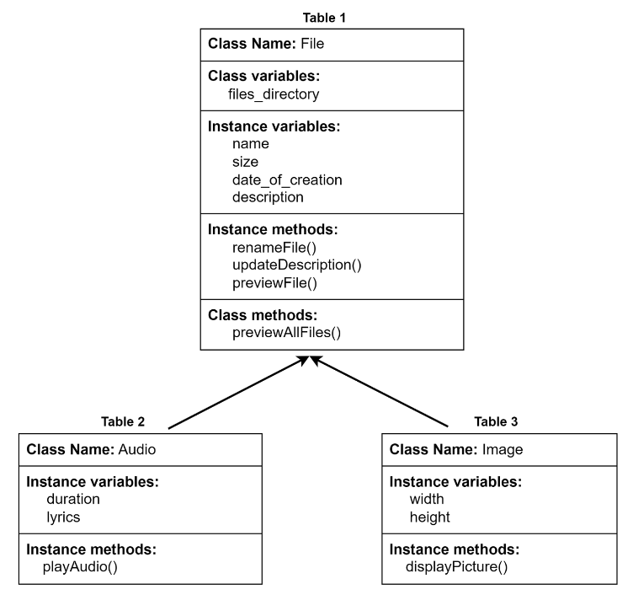

You are given a **File** class. All the necessary variables and methods are shown in table 1.

**previewAllFiles()** is a classmethod which will iterate through each file stored in the class variable **files_directory** and show the file details. You must use the **previewFile()** method to display the file details.

Secondly, implement the **Audio** and **Image** class such that they both **inherit** the File class.

All the necessary variables and methods are shown in table 2 and table 3 for Audio and Image classes respectively.

Audio class has a **playAudio()** method **that uses the method implemented in his parent class to show the file details and also shows the lyrics if available.**

In **Image** class, a parameter (width x height) will be given as a string to create an object, but you need to process it to find the width (first part of the parameter) and height (second part of the parameter) of the image. You can assume that all images will print a rectangle when the **displayPicture()** method is called.

The driver code for the given scenario and expected output is given [here](https://colab.research.google.com/drive/1dc9eMUyZGVw-jeVKbOxMOYQ8IYb6hTjL?usp=sharing).